**RAJKIYA ENGINEERING COLLEGE**

**AHER, TIRWAGANJ, KANNAUJ**

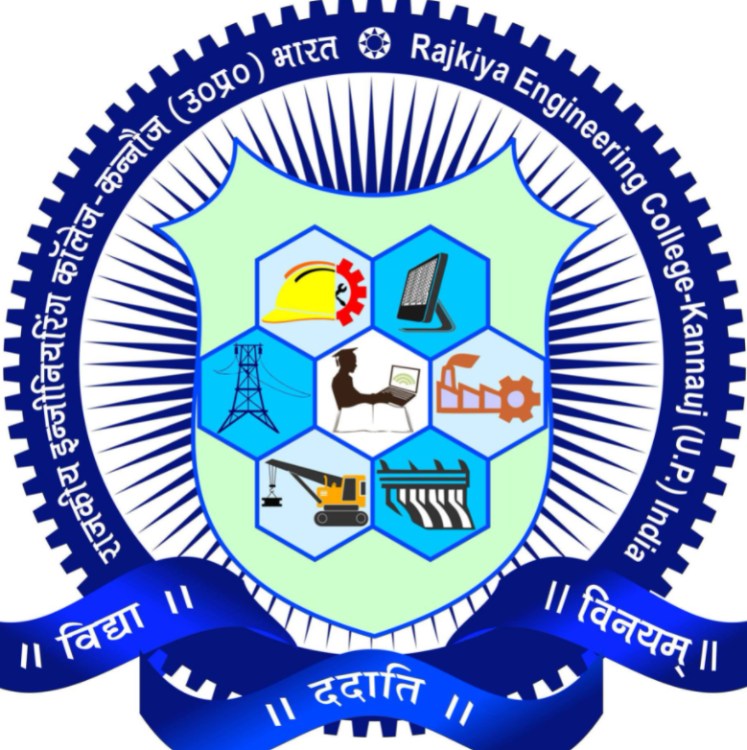

Power System Lab File

KEE (551)

NAME:- ABHISHEK KUMAR SINGH

ROLL NO:-1908390200001

BRANCH:- ELECTRICAL ENGINEERING

SUBJECT:- Power System Lab

KEE (551)

DATE OF SUBMISSION:-

EXAMINER SIGN- TEACHER SIGN-